**Health-Care Domain**

* **Health-care Domain Testing** is a process to test **Health-care** application for various factors like standards, safety, compliance, cross dependency with other entities, etc.
* The purpose of health-care domain testing is to ensure quality, reliability, performance, safety and efficiency of the Health-care application.
* **Why Do We Require An Application In Health-Care Domain..??**

(Note: This Point can be used to answer questions like, what was the need of this application? /What was the business requirement of the application? /What was the business flow of the application you worked on?)

* Whenever a new patient comes to the hospital, we need to do a **new registration** for the patient.
* If existing or new patient needs to schedule an **appointment** with any doctor
* To maintain the **visits** of all patients inside the hospital
* To **maintain the data** of doctors, nurses, other staff etc.
* To **maintain the stock** inside the hospital, the stock can be medicines, surgical instruments, house keeping stock, bed availability etc.
* To submit and validate **claims** for patients.

**Terminologies related to Heath-Care Domain :-**

****1.Insurer:****  
An entity or Insurance Company which creates plan, sell policy and reimburses policy holder or provider for the submitted valid claims.

****2.Policy-Holder:****  
Health-care policyholder (**Insured**) A person or an entity, who buys the policy from the insurer, pays premium to the insurer and sometimes submit claim.

****3. TPA(Third Party Administrator):****  
A person or an entity that manages the claims of policy holder or provider and receives payment for the management from the respective contributor.

(TPA -> Insurance Samadhan => <https://www.insurancesamadhan.com/> )

****4.BROKER:****  
Health-care insurance broker (**Insurance Agent**)  
He is an agent who sells policy to the customers on behalf of insurer and receives commission in return from the Insurer.

****5. Claims –**** “An invoice from the provider to the doctor for the services rendered”.

****6. Co-Insurance –**** A form of medical cost sharing in a health insurance plan that requires an insured person to pay a stated percentage of medical expenses after the deductible amount, if any, was paid.

****7. Co-payment –**** A form of medical cost sharing in a health insurance plan that requires an insured person to pay a fixed dollar amount when a medical service is received. The insurer is responsible for the rest of the reimbursement.

****8. Deductible**** – A fixed dollar amount during the benefit period – usually a year – that an insured person pays before the insurer starts to make payments for covered medical services.

****9. Medicare:**** A federal health insurance program for senior citizen and permanently disabled people.

****10. Medicaid:**** A joint and state program that helps low-income families and individuals pay for the cost associated with medical care.

****11. HIPAA**:** It is a set of rules and regulations which doctors, hospitals, health-care providers and health plan must follow in order to provide their services.

**Name of the Application: PMS (Practice Management Software)**

**Healtrhcare Domain Companies -**

GreenMed / AdvanceMed / PracticeMD / GreenWay / ProviderWay / NextGen / OpenEMR / Medfusion

* **In Which All Departments The Application Can Be Used..??**

The application can be used in all the departments available inside the hospital to provide a smooth service to any patients who is visiting.

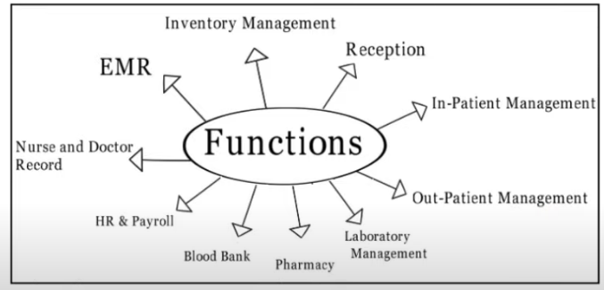

**Business Flow :-**

1. Practice Management Software is having many functionality to manage Hospital/Practice. One of them is **Billing Module**.
2. Most of the Hospital in United State are using **Practice Management Software** for smooth operation in their facility.
3. Using this PMS any Hospital can manage their **Appointment, Scheduling, Maintaining Patient Health Information (PHI), Billing Department, Credit Balance, and Inventory Management.**
4. They can manage their multiple branches using single platform.
5. Using Practice Management Software Hospital can get their reimbursement from Patient Insurance in Short period.

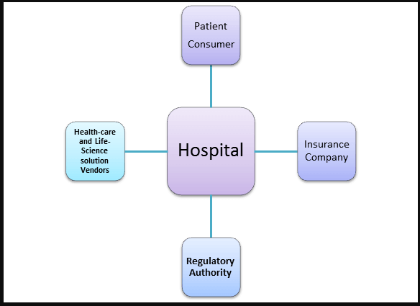

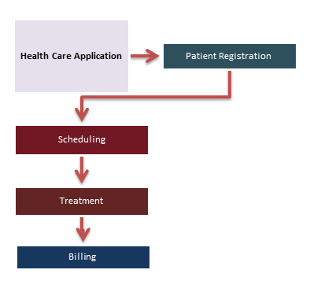

* **Technical Flow:**

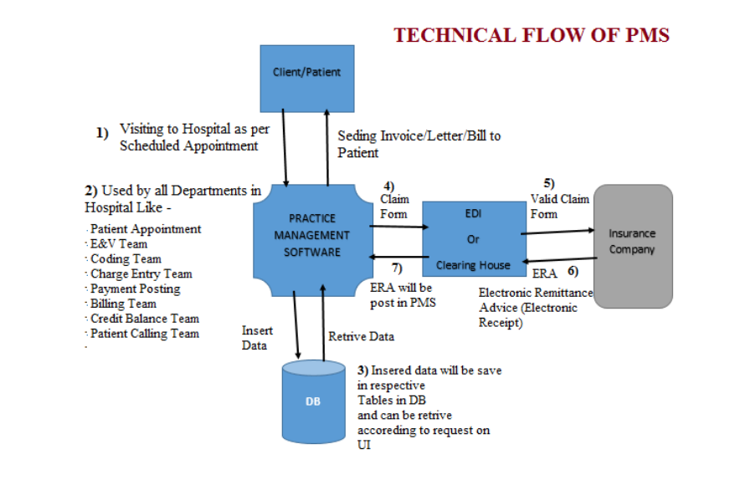

1) When any patient is coming to Hospital for taking service then from usage of PMS will start.

2) If the patient is new for Hospital then need to create new account for that patient in PMS.

3) Who is handing Registration/Patient Appointment team will take patient demographic information and enter into PMS.

4) Doctor will provide the required service to patient and at the same time it will be documented in the form of Medical Records.

5) These medical records will be uploaded into PMS.

6) On the Basis of Medical Records, Coding team will enter service related codes into Practice Management System.

7) Then Charge Entry team will use PMS to enter charges for entered codes by Coding team.

8) From Practice Management Software claim will be bill to patients Insurance Company through selected way – Paper or Electronic.

9) Practice Management Software is integrated with one of the Clearing House or EDI for checking format of the data on claim form and is there any missing information on Claim form which is mandatory.

10) Electronic claim have to pass through EDI / Clearing House and then it will reach to Insurance Company.

11) Once Insurance Company paid for the claim then payment posting team is posting payment on Payment Posting screen.

12) Also if payment received from patient then also posting team is posting payment on Payment Posting screen.